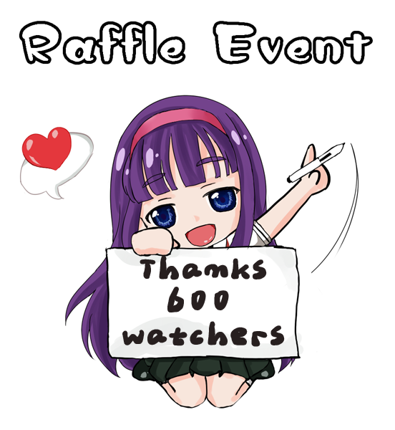
University of Hard Work Raffle

Objective: Review Java by working with arrays, classes, and constructors.
Description: The University of Hard Work is sponsoring a raffle to raise money for the university. Each of the raffle tickets has a unique six digit number. The raffle committee needs a computer application to analyze the results of the raffle, determining the winning tickets. The winning tickets are determined as follows:
- First Prize – The six digit number on the ticket exactly matches the winning number.
- Example: If the number on the ticket is 123456, it is a winner if the winning number is 123456.
- Second Prize – The reverse of the 6 digit number on the ticket exactly matches the winning number.
- Example: If the number on the ticket is 654321, it is a winner if the winning number is 123456.
- Third Prize – Any 3 sequential digits of the 6 digit number on the ticket exactly matches 3 sequential digits in the same position of the winning ticket.
- Example: If the number on the ticket is 123456, it is a winner if the winning number has 123 in positions 1 – 3, 234 in positions 2 – 4, 345 in positions 3 – 5, or 456 in positions 4 – 6.
Instructions: A driver (main class) as well as a programmer-defined class must be used.
The main program (driver) should ask the user to enter the winning 6 digit number. Do this only once. Input from the keyboard, the ticket holder’s name and his/her six digit ticket number. Analyze the ticket to see if it is a winner using the rules for winning above. If the ticket is a winner, display a message indicating the prize won and the holder’s name. Continue to process tickets until there are no more.
When all tickets have been processed, display the total number of first prize winners, second prize winners, and third prize winners.
Requirements:
- The class must be named Ticket.
- The main program (driver) must be named Raffle.
- A driver (main class) as well as a programmer-defined class must be used.
- Submit program through the assignment tool in Moodle2.
- Include a comment stating your name.
- Each student must create his/her own independent program.

